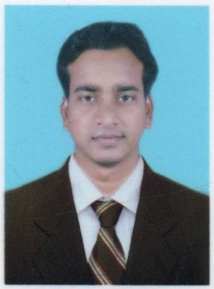Curriculum Vitae

ARUN KUMAR SAHU

At-Chhamunda, PO-Chhamunda, Via-Telkoi,

Dist.- Keonjhar, Orissa, PIN-758084

Email:arunkumarsahu02@gmail.com

Contact No:9337554885

**OBJECTIVE:**

* To become a part of an organization with scope of challenging career & continuous improvement coupled with organizational growth & individual development.

**CAREER HIGHLIGHTS:**

* Presently working as Sr. Officer in Jana Small Finance Bank Ltd. Bargarh, Odisha from 30th October 2019 onwards…
* Having 2 years and 6 months experiences in Axis Bank Ltd. As officer Sales at Keonjhar District of Odisha. From 17th Dec 2015 to 1st July 2018.
* Having 3 years and 6 months experiences in CMS INFO SYSTEM Ltd. at Angul, Odisha. As Cash Officer and Vault Custodian. From 25th May 2012 to 30th Dec 2015.

**WORK PROFILE:**

* Handling of CMS Cash Transation.
* Handling account openings like saving accounts, current accounts, FDs & RDs.
* Funding of CASA Value added.
* Cross Selling of Several Product like LI, GI, MF, Trading etc.
* Loading of Cash in ATM Mechine.

Ecademic Qualification:

IT Skills:

|  |  |  |  |
| --- | --- | --- | --- |
| ***Examination Pased*** | ***BOARD***  ***UNIVERSITY/ INSTITUTE*** | ***YEAR OF PASSING*** | ***PERCENTAGE*** |
| **H.S.C** | **B.S.E., CUTTACK ,ORISSA** | 2006 | 50% |
| **H.S.E** | **C.H.S.E, BBSR, ORISSA** | 2008 | 41% |
| **BSC** | **NORTH ORISSA UNIVERSITY,BARIPADA** | 2011 | 45% |

* Well versed with MS Word, Excel, Power Point, SQL, and Internet.

Strengths and Capabilities:

* Willing to walk extra mile to achieve success fiery ambition.
* Competitive, Efficient, Hardworking and Goal Oriented.
* Excellent commitment and responsible work.
* Taking pride in doing good job and achieving good results within the set duration of time.

Personal Particulars:

* Father’s Name: Kalandi Charan Sahu
* Marital status : Un Married
* Date of Birth : 02.03.1990
* Languages Known : English, Hindi and Oriya

Diclaration :

* I hereby declare that the information furnished above is true to the best of my knowledge.

Date:

Place: Arun Kumar Sahu